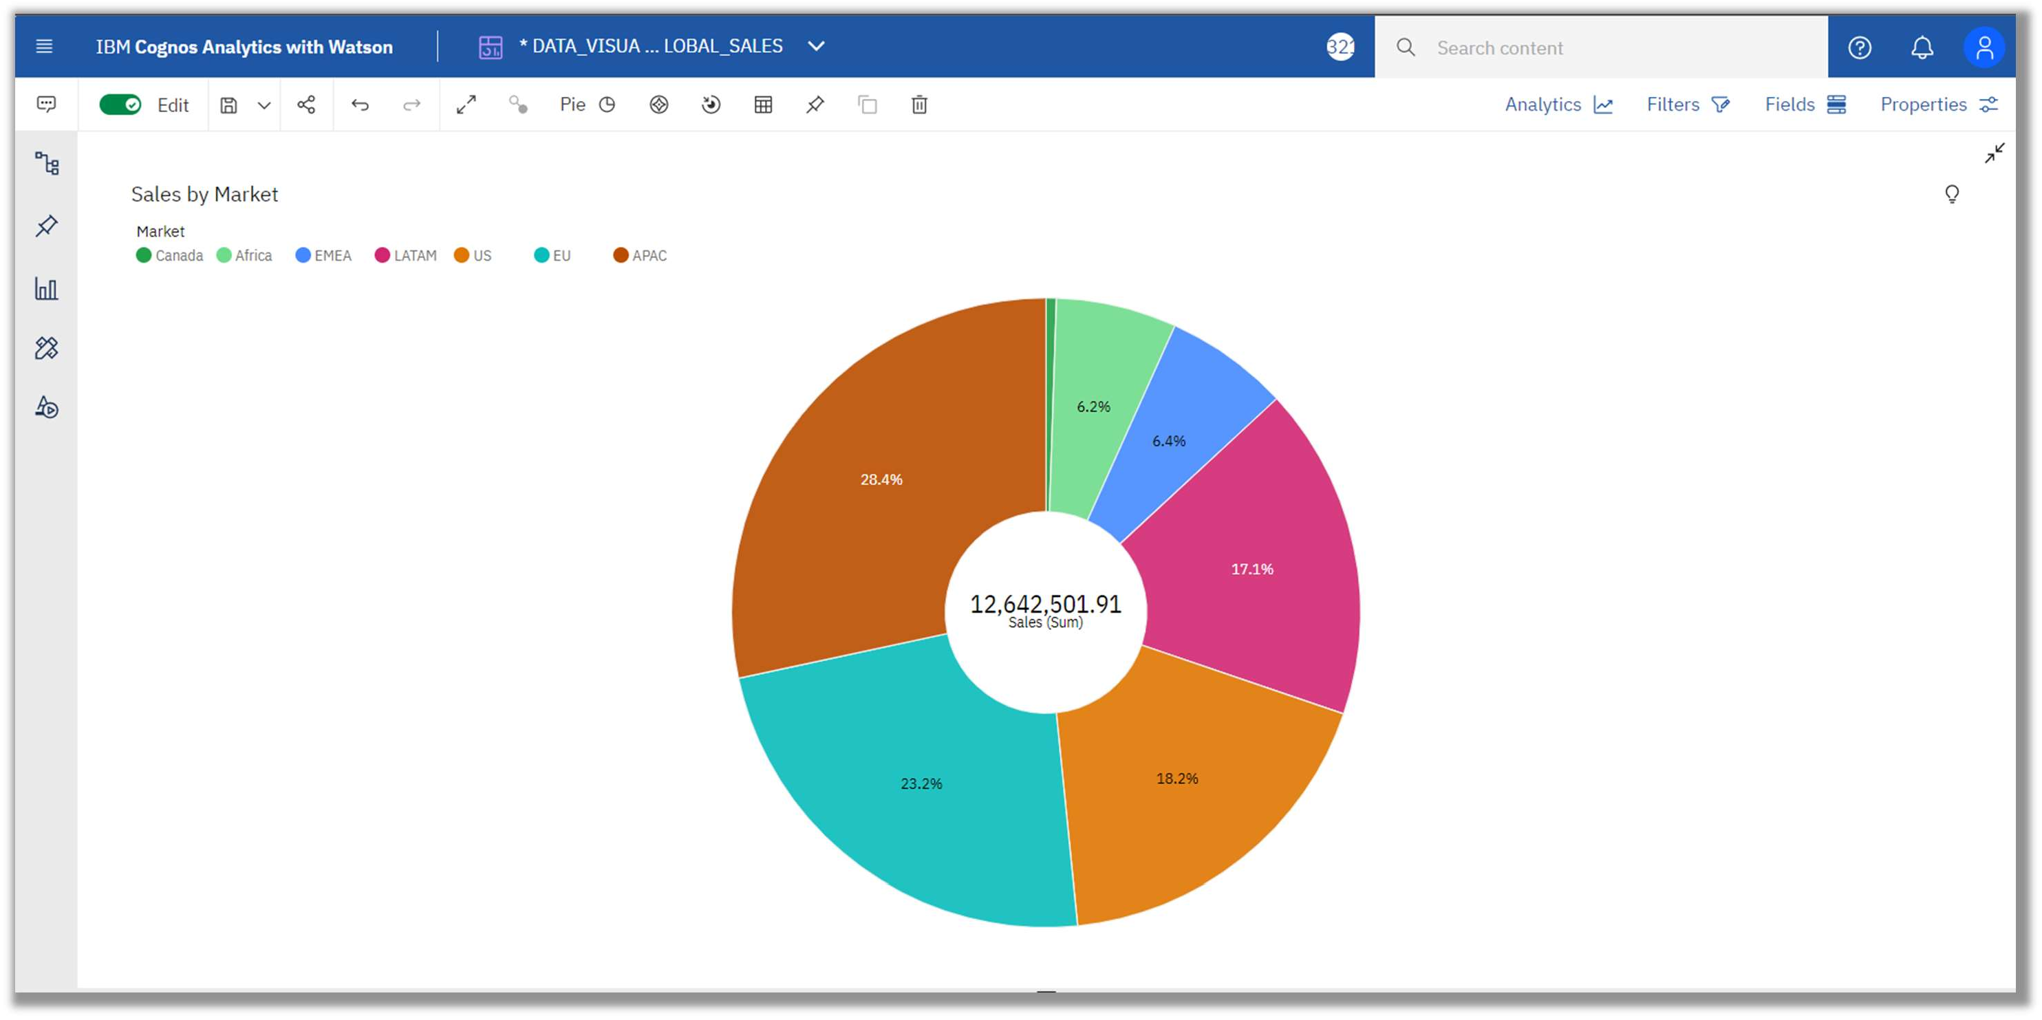

TEAM ID : PNT2022TMID00847

2.SALES BY MARKET